**Haider Nawaz 480239**

**Q no 1:**

#include<iostream>

using namespace std;

int main(){

int b;

int sum=0;

for(int a=1;a<=10;a++){

cout<<"Enter no= ";

cin>>b;

sum=sum+b;

cout<<sum; } }

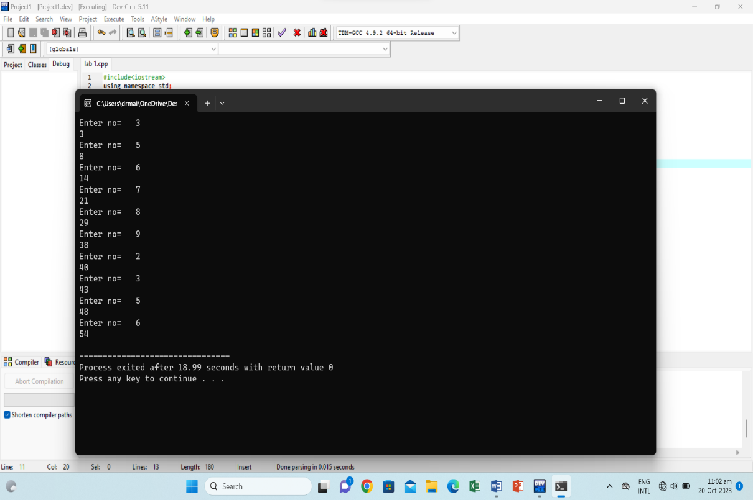

Q no 2:

#include<iostream>

using namespace std;

int main(){

int table;

cout<<"ENTER NO= ";

cin>>table;

for(int a=1;a<=10;a++){

int Ans=table*a;

cout<<table<<'*'<<a<<'='<<Ans<<endl;} }

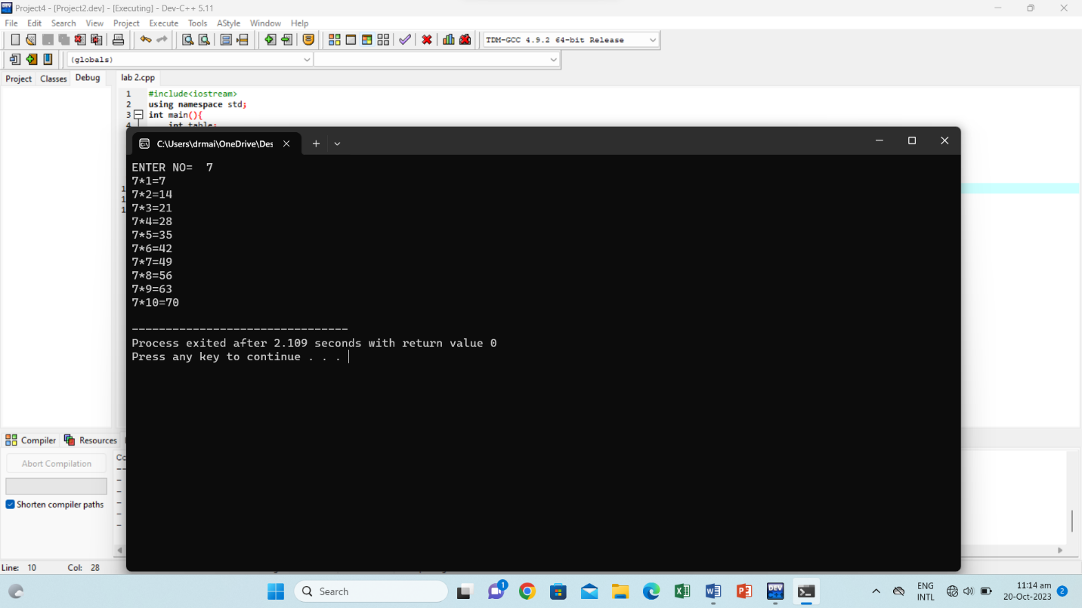

Q no 3:

#include<iostream>

using namespace std;

int main(){

int a;

int factorial=1;

cout<<"Enter a no= ";

cin>>a;

if(a<0)

cout<<"invalid";

else if(a<=1)

cout<<a<<"!="<<factorial;

else{

for(int b=a;b>=2;b--){

factorial=factorial*b;

}

cout<<a<<"!="<<factorial;

}

}

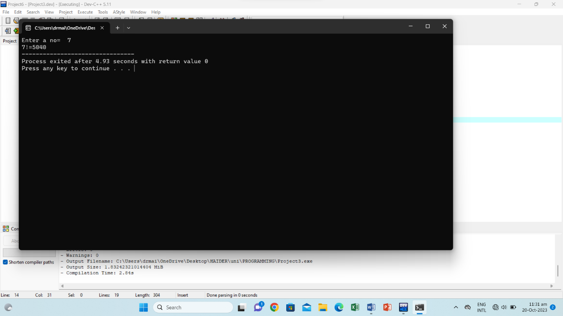

Q no 4:

#include<iostream>

using namespace std;

int main(){

int a,b,c,sum;

cout<<"sequence's length= ";

cin>>a;

cout<<"Enter no 1= ";

cin>>b;

cout<<"Enter no 2= ";

cin>>c;

for(int d=0;d<a;d++){

sum=b +c;

cout<<sum<<" , ";

b=c;

c=sum;

}

}

